Vietnamese Chicken Salad
by Bill Granger from bill's food
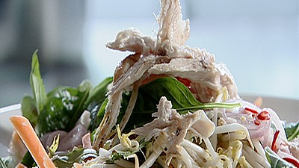  - Method  Chicken Salad  - Preheat the oven to 220°C (425°F/Gas 7).  - Heat a frying pan over a high heat, and while the pan is heating, brush the chicken with olive oil and season with salt and pepper.  - Place the chicken skin-side down and sear for 2 minutes, turn and sear for another minute.  - Put the chicken on a baking tray and cook in the oven for 8 to 10 minutes. Leave to rest for 20 minutes.  - Shred the chicken into thin strips with your hands and place in a large bowl.  - Add the remaining ingredients and toss to combine.  Vietnamese Dressing  - Place all the ingredients in a small bowl and stir until the sugar is dissolved. | Serves 4  A Vietnamese style chicken salad with Vietnamese dressing - is an easy summer meal.  - Ingredients  Chicken Salad  - 3 pieces 200g chicken breast fillets  - 2 tablespoons vegetable oil  - sea salt  - White pepper use black if that is all you have  - 1 cup bean sprout  - 1 cup Vietnamese mint leaf  - 1 cup Asian basil leaf or basil leaves  - 4 cups Chinese cabbages finely shredded  - 1 cup carrot peeled and finely julienned  Vietnamese Dressing  - 60 ml Lime juice  - 60 ml Fish sauce  - 2 tablespoons Rice vinegar  - 1 tablespoon caster sugar  - 2 very finely chopped Garlic Cloves optional  - 3 finely sliced red Asian shallots or 1/2 red onion  - 2 small very finely chopped Red chilli's remove the seeds if you don't like the heat

